This is how you clean the flat

Please, clean the flat before you give the keys to the caretaker.
If you have not cleaned the flat, Petterinkulma will call a cleaner and charge you for the cleaning.

- Kitchen
- Clean the cooker from inside, outside and the back.
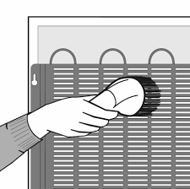
- Clean the hob.
- Clean the refrigerator from inside, outside and the back.
- Vacuum-clean the condenser from the backside from the refrigerator.
- Check that the defrosting pipe from the refrigerator is in the trough.
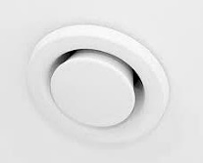
- Wash the kitchen cupboards inside and outside.
- Clean the ventilation valves.

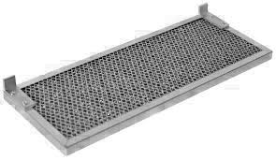
- Wash the hood grease filter.

- Bathroom and toilet
- Wash the toilet seat and the washbasin.
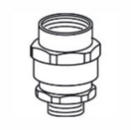
- Clean the floor drains.
- Clean the ventilation valves.
- Check that the suction protection of the washing machine is in place.
The suction protection belongs to the flat.

- Sauna
- Wash the sauna benches.
- Clean the floor drains.
- Clean the ventilation valves.

- Walls, floors and windows
- Vacuum-clean and wash all the floors and wipe the floors with a damp cloth.
- Clean the stains from the windows and walls.
- Wash the windows and the balcony windows Wipe also Venetian blinds.
- Wipe the dust from the ceiling.

- Storage and other places
- Clean the balcony and the storage area.
- Collect the trash and the pet faeces from the front and the back yard.

- Dishwasher connections
- Close the inlet and outlet connection of the dishwasher with original parts.
- Reinstall the cabinet where the dishwasher was.

- Ceiling light sockets and connectors
- Check that the ceiling light sockets and connectors are in place.

- Things that you do not need anymore
- Please, do not take anything else but trash to the trash shelter. Broken goods you can take to Ylä-Savon Jätehuolto. For example, unbroken furniture, electronics and clothes you can recycle in the flea market or recycling centre.
- If we have to transport your things away, we will charge you for the transportation.

